Pamhyr2: a graphical user interface for 1D hydro-sedimentary modelling of rivers
Pierre-Antoine Rouby, Benoît Camenen, Lionel Penard, Léa Kieffer, Théophile Terraz
INRAE, UR RiverLy, centre de Lyon-Grenoble, 5 rue de la Doua, CS20244, 69625, Villeurbanne, France.
pierre-antoine.rouby@inrae.fr, benoit.camenen@inrae.fr, lionel.penard@inrae.fr,
lea.kieffer@inrae.fr, theophile.terraz@inrae.fr

KEY WORDS
1D modelling, sedimentary modelling, user interface

Abstract
In numerical river simulation, one-dimensional models are commonly used to study water level and discharge for large domains or long time series. These models are less time-consuming than two- and three-dimensional numerical models, and require fewer input parameters and allow ensemble runs. To build a one-dimensional hydraulic model, a pre- and post-processing tool is needed for creating reach geometry, specifying initial and boundary conditions, friction coefficients and other numerical parameters. Such a tool needs to ensure the consistency of the model and provide a user-friendly graphical user interface. In this article, we present Pamhyr2, the fully rebuilt version of the PamHyr modelling platform. It is developed using Python, PyQt and MatPlotLib. Pamhyr2 is free and open-source, multilingual and cross-platform (Linux, Windows) and is generic enough to accept various one-dimensional solvers. Pamhyr2 includes and enhances all the features from the previous version: multiple-reach modelling, geometry definition from cross-section data, initial and boundary conditions, friction coefficients, hydraulic structures, lateral inflow, punctual intake and the results visualisation window. In addition, this version includes new features such as pollutants modelling, bedload and suspension sediment transport and bed evolution. This article focuses on the new features. We describe several windows: the creation of sedimentary layers in the river bed, the sediment characteristics for each layer, the sediment, and pollutant boundary conditions and the lateral inputs. These functionalities are illustrated with simple examples and several numerical solvers. We finaly show the visualisation windows for bed evolution and pollutant concentrations.

1. introduction

2. Objective

2.1 History and need
PAMHYR [1] is a graphical user interface for 1D river modeling, available for two solver, one for Mage [TODO cite] studies and the other for RubarBE [TODO cite] studies. These two interfaces are similar, but have their own specific features. They can both be used to: define reach geometry, boundary conditions, lateral inflows, overflows, friction, and structures. In addition, you can run the solver on the study you are editing, and view the solver's results. The two interfaces differ in several respects. Firstly, although both MAGE and RubarBE are multiple-reach compatible, only the MAGE interface enables multiple-reach study editing. Secondly, many small details change from one interface to the next. In addition, the latest MAGE features, for example, are not available for modeling in the interface.
PAMHYR, developed in Java since 1998, suffers from complexity due to highly specific interface, as well as a significant technological debt: Old external library no longer maintained, numerous modifications by multiple developers over a short period of time, with no vision of long-term maintainability.
A total overhaul of the Java code would be too much work, given the technological debt accumulated since the beginning of its development. What's more, the software is only in French and the code is closed (the sources are not available), which is a hindrance to the notoriety of the software as well as to the vitality of development. No significant changes have been made to the application since 2016. PAMHYR is still often used for river modeling [TODO citation example].
In view of the workload involved in modernizing PAMHYR, the decision was made to develop a new version of the software from scratch. This version should be equivalent to the Java version in terms of functionality, and add new features, notably the new MAGE functionalities. The aim was also to have an interface that was more modern, more user-friendly, more flexible, available on multiple platforms and in different languages. The interface must also have a certain degree of generality and be able to adapt to different solvers without major changes to the interface. It's also important that the code is open to contributions, to keep the project as lively as possible.

2.2 Technical choices
From a technical point of view, choices were made on the basis of the above-mentioned objectives (modernity, maintainability, multiplatform, multilingual, user-friendliness, flexibility), as well as: the ease of learning the technology to facilitate contribution to the software, the popularity of the technology in the scientific community and the interoperability of this technology.
We chose Python as our programming language, it is a popular language in the scientific world, but also in many other fields, with lot of very active software libraries to facilitate development. What's more, it's a simple and interpreted language, often recommended for beginners, and practiced by beginners and experienced developers. In addition, there is the PyQT software library that lets you use the Qt GUI library, which is ideal for this project. It is very popular and active, and available on many platforms (GNU/Linux, Windows, MacOS, ...). Qt also includes a number of tools for translating interfaces into different languages. For graphics, the choice fell on MatPlotLib, which is very popular in the scientific community and can be used to draw a wide variety of graphics. For saving studies, the choice was made to use SQLite, unlike the previous version which used a text file formatted in XML. The advantages of a SQLite database, in addition to being supplied with Python, include ease of use, interoperability, formal structuring by table and consistency checking between tables. However, PAMHYR and Pamhyr2 study files are incompatible, and old studies have to be recreated for this version.
This new version of PAMHYR remains closely linked to the MAGE solver with which it is supplied. But the ambition of flexibility and genericity gives us the goal of developing an interface that can be adapted to other solvers. There must be two solutions for using a solver with Pamhyr2: either the solver addapt to Pamhyr2, or Pamhyr2 addapt to the solver. So Pamhyr2 must integrate a generic output containing the study data that can be used by other solvers, which will be launched via an external executable, and then a generic results input that must be supplied by the solver. In addition, Pamhyr2 must be able to handle the execution and reading of results for specific solvers, and the addition of a solver to PAMHYR must be reasonably easy for the solver developer.
For the license, we have opted for GPLv3, which guarantees that the code will remain free for modification, correction, improvement, distribution, and use by anyone.

3. Production

3.1 New version of PAMHYR
Pamhyr2 currently features the following interfaces: Editing of network, geometry, boundary conditions, friction, initial conditions, solver parameters, as well as the interface for launching a solver and displaying hydraulic and sediment results.

3.1.1 River network
Network editing (Figure 1) is performed via a window featuring a graphical network area and two tables, one with a list of nodes and the other with a list of reaches. The graphic area lets you add, delete and move nodes. It can also be used to link nodes in the network by arrows that represent reaches. The color of the node in the graphics area depends on whether it is a downstream, upstream or internal network node. If there is more than one reach, you can use this interface to select a reach, which will then be selected for editing in the following reach-dependent windows. It is also possible to deactivate reaches, in which case they will not be used when the solver is run. Tables can be used to edit additional information on nodes and reaches, such as their names.
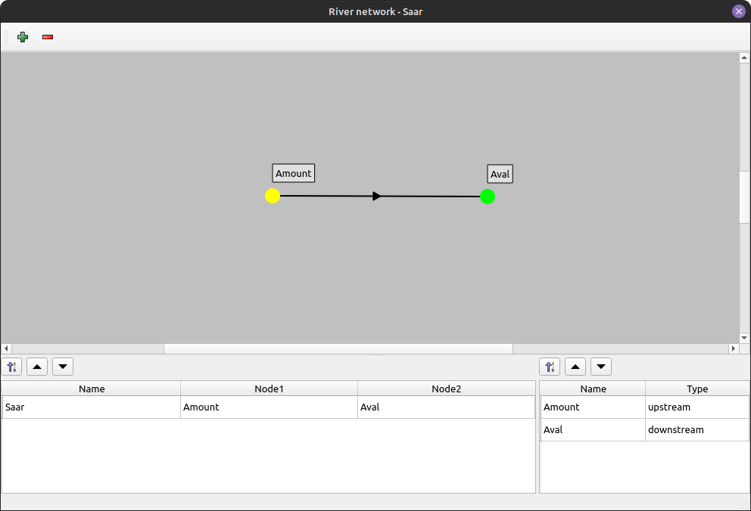

Figure 1: Network window for Saar river with only one reach.

3.1.2 Geometry
Geometry editing (Figure 2) is linked to a reach; by default, the reach used will be the last reach selected in the network window. This window contains a table with the list of reach profiles (Figure 2 zone 1) and three graphics. A top view based on the XY positions of the profile points (Figure 2 zone 2). A side view with the height of the lowest point of each profile (Figure 2 zone 3). Finally, cross-section of the currently selected profile with the previous and next profiles dotted (Figure 2 zone 4). Each profile is defined by a Kilometer Point (KP) and an optional name. It is possible to add profiles and then select them to access an editing window, or to import cross sections from file. Profile editing takes the form of a table showing the raw data of the points that make up the profile, and a graph showing the current profile.

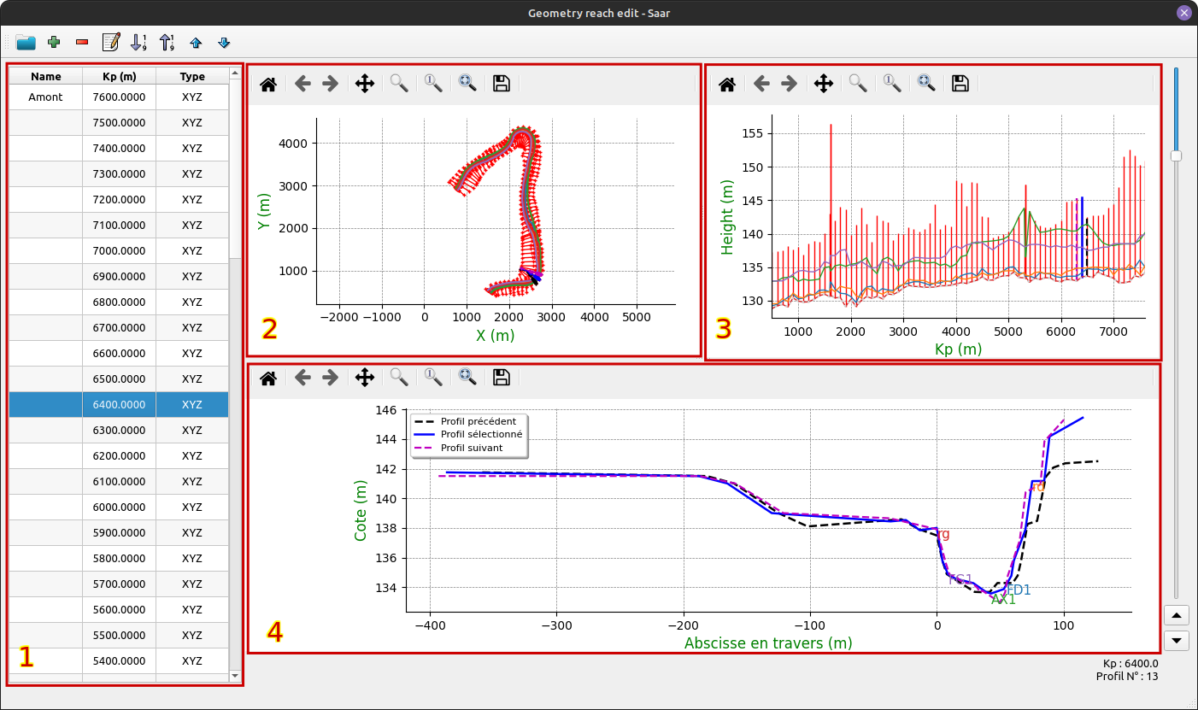

Figure 2: Geometry window for Saar river on the unique reach Saar.

3.1.3 Boundary condition
Boundary conditions (BC) are associated with a network node. There are different types in three different categories: Liquid, solid and suspension. To create a new BC, use the + button and associate a node and a type in the table, then you can edit it. Editing a BC (Figure 3) takes the form of a two-column table (the type of column varies according to the type of BC) and a graph representing the data. Data can be copied and pasted from a spreadsheet, or edited by hand.

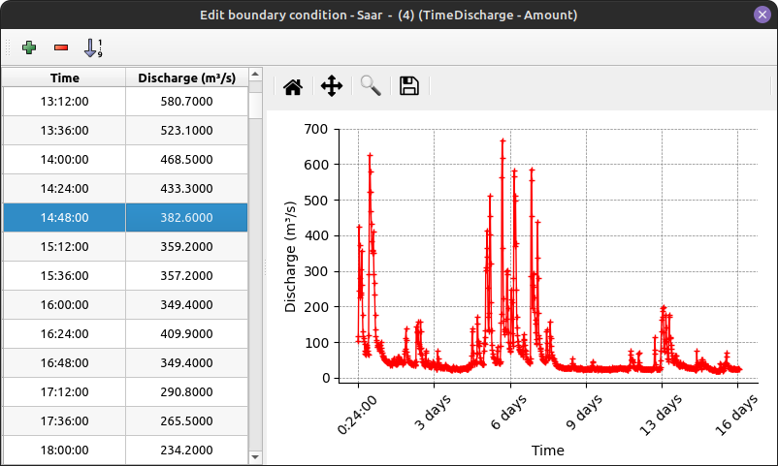

Figure 3: Edition window of boundary conditions for Saar river upstream node.

3.1.3 Lateral contribution
The user interface for lateral contributions is similar to that for boundary conditions, except that it applies to a part of a reach between two KP, and not to a node.

3.1.4 Friction

Friction editing is linked to a reach, a friction coefficient is defined and then applied to a portion of the reach between two KP (Figure 4). Friction is defined by two Strickler coefficients, one for the river's main channel and one for the flood plain.

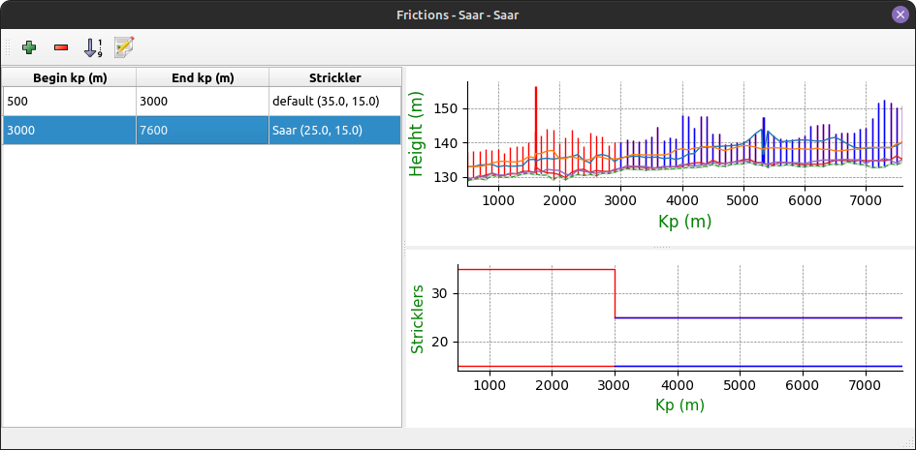

Figure 4: The reach friction edition window with Saar study.

3.1.5 Initial conditions
The initial conditions (Figure 5) are also linked to the reach, corresponding to the water level and flow at the initial time of the simulation. These two values can be defined separately for each reach profile. It is also possible to use predefined functions to generate a water line and flow rate.

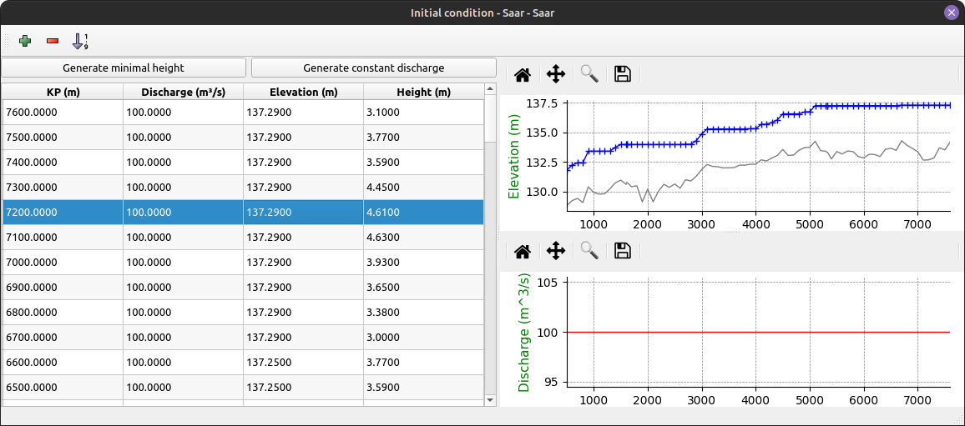

Figure 5: Initial condition window for the Saar study and the Saar reach of river.

3.1.6 Solver running
Solver parameters are defined using a key/value table specific to each type of solver known to Pamhyr2. You can select and run the desired solver from the list of configured solvers. Then a window appears with a text area where you can follow the progress of file export and solver output (Figure 6 zone 3). You can also pause, stop or restart the solver using buttons Figure 6 zone 1. Once the simulation has finished, you can open a solver trace file, and if the simulation has finished correctly, you can open the results using the “results” button Figure 6 zone 2.

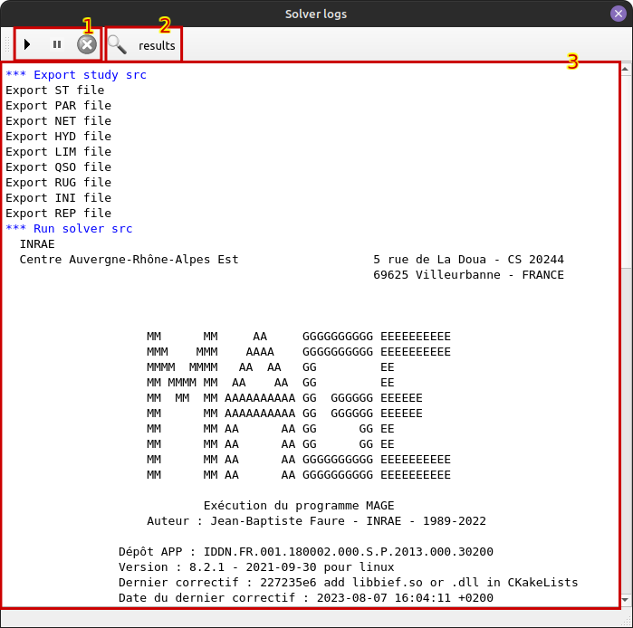

Figure 6: Solver log window for “Elargissement” tests case.

3.1.7 Results presentation
The post processing window is made up of tables allowing you to select the reaches, profiles, and timestamps for visualizing the results. The results are presented in different tabs according to the type of data displayed. The Figure 7 shows hydraulic data with water level at a given reach, profile, and time. The graphs shown here are the same as those in the geometry window, with the addition of water level results at a given time.

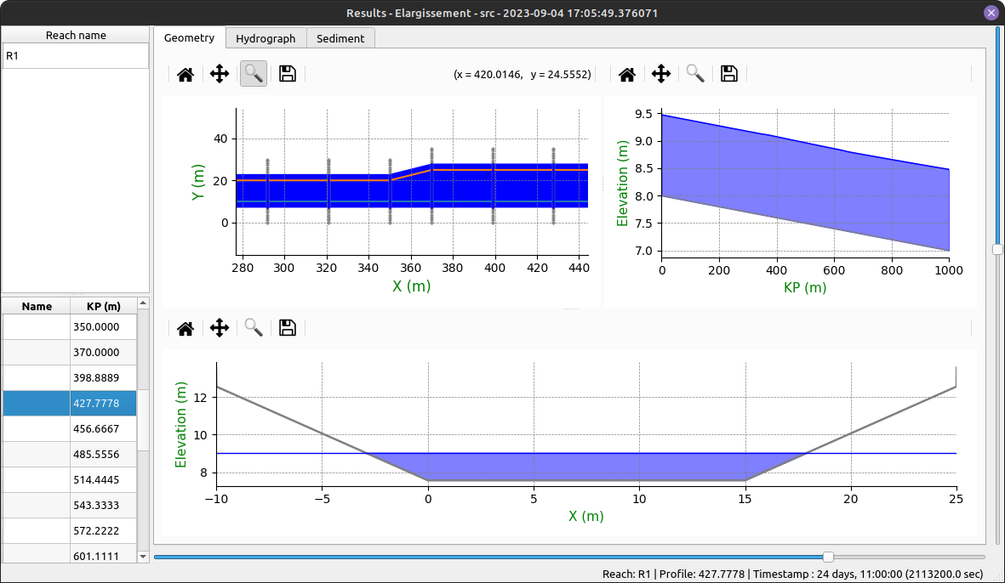

Figure 7: Hydraulic results window for “Elargissement” tests case at timestamps 2113200,0 sec for reach R1.

3.2 New features
Some new features are already implemented in Pamhyr2. First of all, the software is multilingual with English and French currently available. An other very useful enhancement, is the possibility to use the “Ctrl+Z” and “Ctrl+Shift+Z” shortcuts to undo and redo actions to go backward or forward.
Another novelty lies in the initial conditions window. Previously the water line could be generated by constant height or altitude. It is now possible to give a minimum height with an increasing function from downstream to upstream, thus avoiding physically unrealistic water holes and getting a little closer to a real and physically coherent water line (Figure 5).
An important new feature in this version is the presence of sediment layers. They can be defined as show Figure 8. Sediment layers can be applied separately for each cross sections (Figure 9). As with friction, they must first be defined and then applied to a profile. They can also be applied separately to each point of a cross sections. Layers are defined by a height, a median diameter (D50), a sediment diameter range (Sigma) and a critical shear stress as described in Pierre Balayn PhD[4]. The visualization of sedimentary results is currently done using a plot of the river profile, which shows the evolution of the bed bottom and the thickness of layers as a function of time (Figure 10).
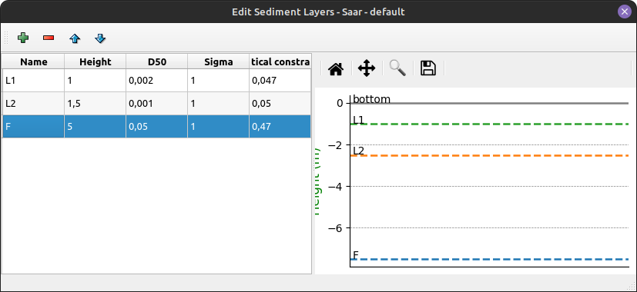

Figure 8: Sediment layers definition window for Saar study

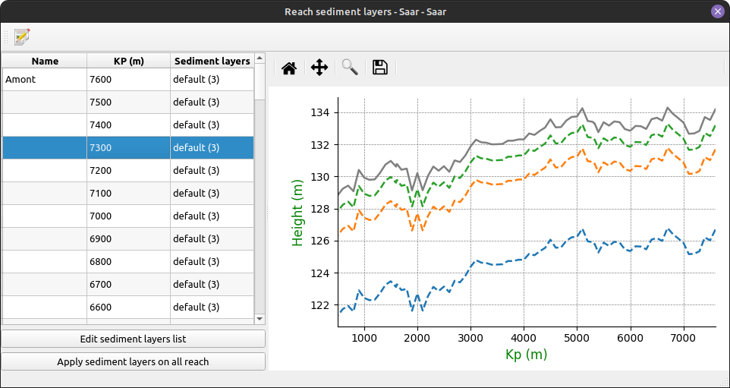

Figure 9: Sediment layers apply window for the reach Saar on Saar study

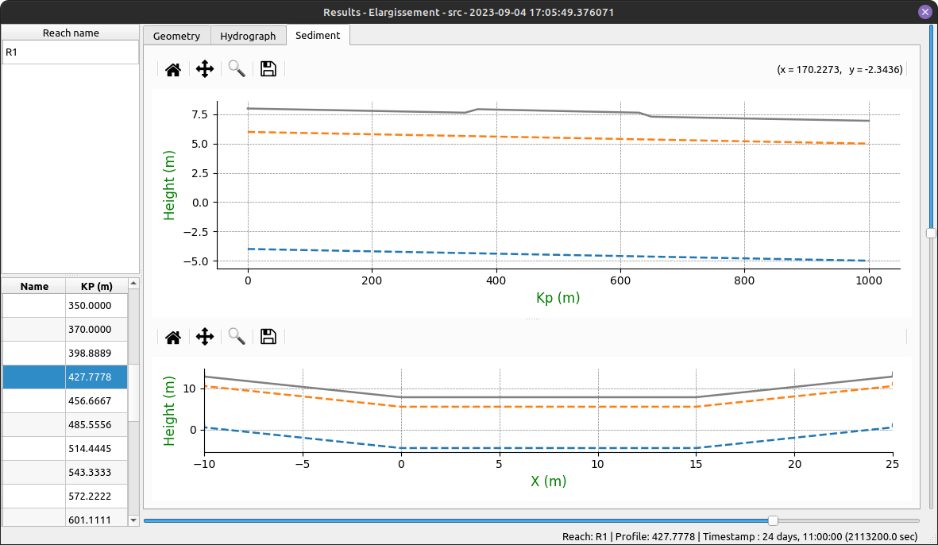

Figure 10: Sedimentary results window for “Elargissement” tests case at timestamps 2113200,0 sec for reach R1.

4. Future work
Functionalities that may or may not have been present in the old PAMHYR, enabling the definition of structures, traps, suspended solids or dissolved pollutants in water, have yet to be developed. Additional options for visualizing results also need to be added. One possibility would be a graph generation tool that would allow the user to select absis and ordinate values, as well as the time range, to create a customized graph. We can also imagine a code-editing window to enable the user to define his own Matplotlib drawing function, which would be saved in the study. Presentation work is also planned to harmonize the application's icons and visuals (images, graphics, etc.). The aim is to make the application clearer and more user-friendly.
Supporting new solvers and generic solvers will also be an important part of the remaining work. To use any solver, we need to define a generic output format for Pamhyr2 that is simple enough to be given as solver input without major code modification, or that can be processed by a simple Python script (for example). The same applies to the results file that Pamhyr2 will have to read. The main avenues for these generic formats are :
- SQLite, because it's easy to use and the library is compatible with most programming languages,
- HDF5, a hierarchical file format widely used in scientific circles and compatible with many programming languages.
As the project progresses, it becomes more and more complicated to test all the functionalities by hand. A suite of tests and unit tests is needed to prevent regression bugs and ensure that the code remains maintainable. For the moment, no tests have been defined. Unit tests will have to be developed on the model and each sub-module will have to include tests, but higher-level functionalities will also have to be tested, such as the recording and playback of a complete study. As for the graphical part, it will be difficult to test automatically, so tests will continue to be carried out manually.
Full documentation must also be provided to give users an overview of the features offered by Pamhyr2. This documentation must include descriptions of the configuration options, as well as explanations and examples of how to use each feature. In addition, this documentation must include a section for contributors and developers, with a technical presentation of the application, as well as a presentation of the translation, development and debugging tools available.
The French translation of Pamhyr2 is still incomplete, and work is needed on translating technical terms. For translations into other languages, we hope that external contributors will take on this work, but no languages other than English and French are currently planned on our part.
The application packages are currently available for GNU/Linux and Windows, under GNU/Linux a “.tar.xz” archive is available for download. It contains a “pamhyr” executable and all the software libraries needed to run it. It also contains a version of MAGE compatible with this version of Pamhyr2. For Windows, this is an installer for application and a compatible version of MAGE. Once installed, you can launch PAMHYR without any further action on your part. An installer for GNU/Linux systems is a work in progress. There are many choices for creating an installer, but their scope depends on the distribution for which they are intended. “.deb”, for example, is intended for Debian distributions and their derivatives (Ubuntu, Linux Mint, ...). But there are other, more generic options.

5. Conclusion
After a great deal of preparatory work and several months of development, Pamhyr2 is currently in version “v0.0.0” and contains almost 20,000 lines of Python code. It allows you to create a minimal study, run a MAGE simulation and visualize some of the results obtained, all with a more user-friendly interface. But the software is still unstable and under development, with critical bugs and many modifications and improvements still to be made before it can really be used by everyone. What's more, even though many of the features of the original version of PAMHYR are already available (see 3.1 page 2), there are still many to be added.

REFERENCES and Citations
[1] Faure, J. (2013). An Integrated Simulation platform - PAMHyR. In John Wiley & Sons, Inc. eBooks (pp. 245–252). https://doi.org/10.1002/9781118557891.ch21
[2] Faure, J. (2017). Développement d’Adis-TS. OSR4 | Action V.1. https://hal.science/hal-03749339
[3] Camenen, B., Faure, J., Décanis, S., & Diéval, L. (2022). A 1D Numerical Tool for Real Time Modelling of a Complex River Network. In Advances in Hydroinformatics (pp. 41–52). https://doi.org/10.1007/978-981-19-1600-7_3
[4] Balayn, Pierre. (2001). Contribution à la modélisation numérique de l'évolution morphologique des cours d'eau aménagés lors de crues. Université Claude Bernard - Lyon 1

Corresponding author
Corresponding author
MAGE: https://gitlab.irstea.fr/jean-baptiste.faure/mage
RubarBE: https://gitlab.irstea.fr/theophile.terraz/rubarbe
Python: https://www.python.org/
PyQt: https://pypi.org/project/PyQt5/
Qt: https://www.qt.io/
MatPlotLib: https://matplotlib.org/
SQLite: https://www.sqlite.org/index.html
GPLv3: https://www.gnu.org/licenses/gpl-3.0.en.html
HDF5: https://www.hdfgroup.org/solutions/hdf5/

